

**POL101: Introduction to Political Science**

* Sec:18
* Topic: **Intergovernmental Organization**
* Semester: Spring ‘21
* Submitted to:
  + **Mizanur Rahman**
* Submission Date: 24-03-2021

Submitted by: **Group-03**

|  |  |  |
| --- | --- | --- |
| Name | ID | Subtopic |
| Hafsa Monir | 1831062047 | UN |
| Sadia Afsana Proma | 1931118615 | EU |
| Udyan Saha Upal | 1821359042 | SAARC |
| Humaira Sarker Toma | 1811473611 | WHO |
| Sheikh Shaiful Islam Sonet | 1811941643 | WFP |

Contents

**United Nation** 4

Introduction 4

United Nation System 5

Food and Agriculture system: 5

UNESCO: 5

World Tourism Organization (UNWTO) 5

UNICEF (United Nations International Children's Emergency Fund) 5

*International Labour Organization (ILO)* 6

United Nations Environment Programme (UNEP) 6

**European Union** 6

**SAARC**(South Asian Association for Regional Cooperation) 9

Introduction 9

History 9

Principles & Objectives 10

Principles of SAARC 10

Objectives of SAARC 10

Area of Co-operation & latest Development 11

**World Food Programme (WFP)** 12

Introduction: 12

The birth of WFP: 12

Food for Development: 12

Managing Food Aid Resources: 13

WFP’s Strategic Plan: 13

WFP’s Strategic Goal: 14

WFP’s Strategic Result: 14

Latest Development: 14

**World Health Organization ( WHO)** 15

Introduction 15

Background 15

Value 16

Activities 16

Policies and objectives 17

Response to the COVID-19 pandemic 17

Administration and support 18

**References** 18

Intergovernmental organization (IGO) refers to an entity created by treaty, involving two or more nations, to work in good faith, on issues of common interest. An intergovernmental organization (IGO) or international organization is an organization composed primarily of sovereign states or of other intergovernmental organizations. IGOs are established by a treaty that acts as a charter creating the group. Treaties are formed when lawful representatives of several states go through a ratification process, providing the IGO with an international legal personality. Intergovernmental organizations are an important aspect of public international law.(*Intergovernmental Organization - Wikipedia*, n.d.)

Here, we are discussing about some intergovernmental organization like UN, EU, SAARC, WFP, WHO.

# **United Nation**

## Introduction

UN is an internal government that promotes International co-operation. Their purpose is to maintain internal harmony and security. There are many specialized agencies that fulfill the duties of each primary organ of UN. There are 6 primary organ that are “the General Assembly (the main deliberative assembly, the Security Council (decides certain resolutions for peace and security), the Economic and Social Council (assists in promoting international economic and social cooperation and development), the Secretariat (provides studies, information, and facilities needed by the UN), the International Court of Justice (the primary judicial organ), the United Nations Use the "Insert Citation" button to add citations to this document.

Trusteeship Council (inactive)” (*List of Intergovernmental Organizations,* n.d.)

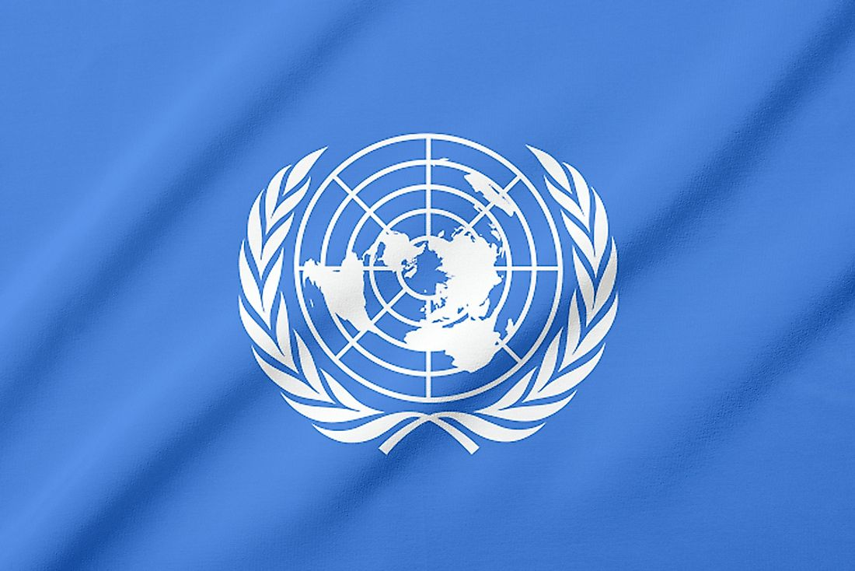

Courtesy: www.worldatlas.com

The UN also includes various Funds, Programs and [specialized agencies](https://en.wikipedia.org/wiki/List_of_specialized_agencies_of_the_United_Nations). Some of them are mentioned below.

## United Nation System

### Food and Agriculture system:

The main goal of this system is to defeat hunger with international effort. They serve both developing and developed countries; also, countries that are transitioning to modernize by helping them improve their agriculture, fisheries, land source, water source and ensuring that everyone gets good nutrition. It also provides technical assistance to projects, conduct research, operates educational and training program and collects data on agricultural production, output and development. It has 197 member states and there headquarter is in Rome Italy.

### UNESCO:

The United Nations Educational, Scientific and Cultural Organization (UNESCO) aim is to promote world security and peace by the help of international cooperation in culture, science and education. Its mission is also to sustain development and human rights through collaboration among nation. It has 193-member state. It also sponsors project that protect independent media, provides technical education and training, improve literacy, advance science, preserve reginal and cultural history and promote cultural diversity. It also helps in disseminating and translating world literature, builds international cooperation agreements to secure [World Heritage Sites](https://en.wikipedia.org/wiki/World_Heritage_Site) of natural and cultural importance, creating inclusive knowledge societies through communication and information, bridging the [worldwide digital divide](https://en.wikipedia.org/wiki/Global_digital_divide) and defending human rights. Several initiative and global movement were launched by UNESCO, such as [Education For All](https://en.wikipedia.org/wiki/Education_For_All), to further advance its core objectives.

### World Tourism Organization (UNWTO)

“It promotes tourism as a driver of economic growth, inclusive development and environmental sustainability and offers the sector leadership and support in advancing knowledge and tourism policies worldwide “(*World Tourism Organization* , n.d.).

It’s headquarter is in Madrid, Spain. It implements global code of ethics for tourism so that the negative impact can be minimized and maximize the socio-economic development through the contribution of tourist. It promotes tourism so that sustenance development goals can be achieved by UN. It is geared towards fostering sustainable development [eliminating poverty](https://en.wikipedia.org/wiki/Poverty_reduction) and peace worldwide.

### UNICEF (United Nations International Children's Emergency Fund)

Its aim is to provide for humanitarian and developmental aid to children worldwide. It has a presence of 192 countries and its territories. UNICEF's activities include providing [treatment](https://en.wikipedia.org/wiki/Antiretroviral_drug) for mothers and children with [HIV](https://en.wikipedia.org/wiki/HIV), give immunizations and disease prevention, improving [sanitation](https://en.wikipedia.org/wiki/Sanitation), enhancing childhood and [maternal nutrition](https://en.wikipedia.org/wiki/Maternal_nutrition), promoting education, and in response to disasters, providing [emergency relief](https://en.wikipedia.org/wiki/Emergency_relief). UNICEF depends entirely on the contribution of the private donor and Government. “In 2018, UNICEF assisted in the birth of 27 million babies, administered [pentavalent vaccines](https://en.wikipedia.org/wiki/Pentavalent_vaccine) to an estimated 65.5 million children, provided education for 12 million children, treated four million children with [severe acute malnutrition](https://en.wikipedia.org/wiki/Severe_acute_malnutrition), and responded to 285 humanitarian emergencies in 90 countries” (*UNICEF*, n.d.). During 2020 Covid-19, UNICEF, WHO along with other agencies provided guidelines.

### International Labor Organization (ILO)

Its aim is to advance in social and economic justice by setting international Labor standard. The standard ensures that work is productive, accessible and sustainable word wide keeping with the condition of freedom, security, equity and dignity. They protect freedom of association, elimination of child labor, forced labor. It also helps to recognize the rights of the collective bargaining and the elimination of the of [discrimination](https://en.wikipedia.org/wiki/Discrimination) in respect of occupation and employment. In the UN system, organization have tripartite structure: all standard policies and programs require approval and discussion from government, employers and workers. This is maintained in ILO’s three main bodies: The International Labor Conference, which makes international Labor standards; the Governing Body, which decides the agency's budget and policy and act as an executive council; and the International Labor Office, which implements activities and administers the organization, it acts as a permanent secretariate.

### United Nations Environment Programme (UNEP)

It was established to help UN to address better coordination and comprehensive response to many interrelated issues of drug abuse, illicit trafficking, political corruption, criminal justice, crime prevention and international terrorism. By three primary function these goals are pursued. They are research, guidance and support to governments in the adoption and implementation of various crime-, terrorism-, corruption-, and drug-related conventions, protocols and treaties, as well as financial/technical assistance to said governments to face their respective challenges and situation in these fields (*United Nations Office on Drugs and Crime*, n.d.).

Long term aim of the office is to better equip the government to handle terrorism, crime, drug and corruption-related issues, to have more knowledge about these issues among governmental institutions and agencies, and also raise more awareness of said matters in public opinion, globally, nationally and at community level.

# **European Union**

The European Union is a geopolitical and economical organization that covers a large part of the European continent. Its establishment is based on many agreements. Just as many states have joined the European Union, and many states have separated from the European Union. The edges of the EU will probably continue to expend further out as there are other countries in various stages of trying to become a member. The citizens of member countries are automatically European Union citizen as well. If someone is a citizen of any of those countries, he/she is free to live, work, and retire in any of the others. In 1945 when whole Europe had ruined after World War 2 the British Prime Minister Winston Churchill came up with an idea that was, ‘to bind the nation so tightly together that a future war would be impossible’. So 6 countries signed up to the **European Economic Community** later in 1993 it was renamed to the **European Union**. Now, the EU has 27 member states.

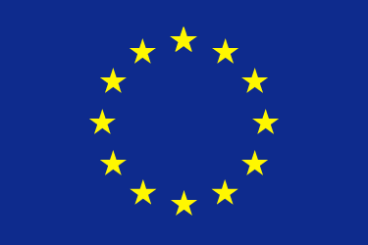

Courtesy:Logo of European Union| www.britannica.com

From the beginning the EU set goal for its member. Promoting peace is the main goal and value, EU always works for the wellbeing of its citizens. The EU offers its citizens freedom, security, and justice without having any internal borders. The sustainable development of the EU balanced the economic growth and price stability; environmental protection and social progress also includes in the sustainable development. Reduce discrimination, promote technology, and enhance economy is the most important goals of the EU. 27 countries have different culture and language the EU focuses to respect its linguistic diversity. The EU values its human dignity. Human dignity has to respected and protected and it’s the basis of fundamental rights. The EU is a democratic organization. The EU citizens have the right to vote in the European parliament election also they can stand as a candidate. One of the valuable laws of the EU is ‘Equality’. The EU gives the equal rights to all the citizens. The law of equal pay for equal work became part of the Treaty of Rome in 1957. The EU is based on the law everything it does is founded on treaties and democratically agreed by the EU members.

Peace, stability, and growth have been delivered by the EU from more than half a century. It increases the living standards of the EU citizens. The EU launched its own a single European currency ‘The Euro’. 19 countries and 340 million EU citizens use the currency as their national currency. In 2002 the euro was introduced to the EU citizens. The **European central bank** and **European commission** are maintaining the value and stability of Euro and to establish the criteria for EU countries to enter the euro zone. Because of the abolition of border controls between EU countries the citizens can travel freely. The main economic engine of EU is the single market. The single market provides the most goods, services, money, and freedom of the people. The European Union is the largest trade center in the world. It has the largest exporter of manufactured goods and services and the largest import market for hundreds of countries. Free trade among its members was one of the main principles of the EU. This is possible because of the single market. It is also committed to liberalizing world trade beyond the EU's borders.

The UK voted to leave the EU in 2016 and officially UK left the EU in 31 January 2020. Because of the Brexit the companies of UK suffer a lot many companies shifted to other EU countries like Ireland, many people also shift to the other EU countries cause when UK was with the EU the people of UK has 27 countries to apply for jobs and studies. But when UK leave the EU the people lost a great opportunity to search jobs, for this reason few people leave the UK too. When the UK was in the EU, companies could buy and sell goods across EU borders without paying taxes and there were no limits on the amount of things which could be traded, but after the Brexit the UK have to pay tax for trade that happened between EU and UK. The business and companies face a huge problem, because they can’t promote, sell, and export or import products as before. They have pay tax for every single trading for that the prize of every product inside the UK increase which is a trouble for the people of UK. However, the freedom of living, studying and working the UK and the EU comes to an end after the Brexit, so the travelers and the student who studying outside the UK suffer a lot. For the Brexit the economy of UK drops 6% in this year. The fact that the UK was at the time the world’s fifth largest economy, and second largest economy in the EU, made the likely damage to the EU’s prestige and its loss of ‘weight’ in international affairs all the more serious. However, the greatest fear that Brexit provoked among EU leaders was the fear of ‘contagion’, a rapid and uncontrolled spread of populist Euroscepticism from one member state to another, which could see the EU unravel from within. The EU sought to counter this possibility by ensuring, at minimum, that the UK’s trading position with the EU would not be more favorable after Brexit than it was before, the EU may benefit from the UK’s departure. (Heywood)

The EU has a significant impact over all the EU countries economically, politically, socially, and culturally. It’s the largest trade center in the world and helps the victims of man-made and natural disasters worldwide and supports over 120 million people each year. Every member state of EU is being mostly benefited in every sector especially in economy, politics, and freedom of living. Overall, the EU plays an important role in the world economy and politic.

# **SAARC**(South Asian Association for Regional Cooperation)

## Introduction

The South Asian Association for Regional Cooperation (SAARC) is the regional intergovernmental organization and geopolitical union of countries in South Asia. Its members are Bangladesh, Afghanistan, Bhutan, India, the Maldives, Nepal, Pakistan and Sri Lanka. The SAARC comprises 3% of the world's area, 21% of the world's population and 4.21% of the global economy as statistics of 2019.(*South Asian Association for Regional Cooperation - Wikipedia*, n.d.)

The regional organization was established on December 8, 1985.There were initially seven member states that are mainly located in South Asia. In April 2007, at the Association's 14th summit, Afghanistan became its eighth member. The Headquarter of SAARC is in Kathmandu, Nepal.(Islam Toriqul & Karim Ershadul, 2019)

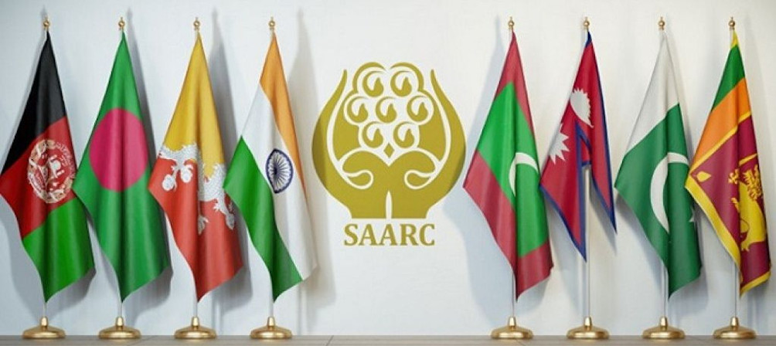

Courtesy: www.aidiaasia.org

## History

In the ending years of the 1970s, the seven inner South Asian nations that included Bangladesh, Bhutan, India, the Maldives, Nepal, Pakistan, and Sri Lanka agreed upon the creation of a trade bloc and to provide a platform for the people of South Asia to work together in a spirit of friendship, trust, and understanding. **President Ziaur Rahman** later addressed official letters to the leaders of the countries of the South Asia, presenting his vision for the future of the region and the compelling arguments for region. During his visit to India in December 1977, Rahman discussed the issue of regional cooperation with the Indian Prime Minister, Morarji Desai. In the inaugural speech to the Colombo Plan Consultative Committee which met in Kathmandu also in 1977, King Birendra of Nepal gave a call for close regional cooperation among South Asian countries in sharing river waters.(*South Asian Association for Regional Cooperation - Wikipedia*, n.d.)

In 1983, the international conference held in Dhaka by its Ministry of Foreign Affairs, the foreign ministers of the inner seven countries adopted the Declaration on South Asian Association Regional Cooperation (SAARC) and formally launched the Integrated Program of Action (IPA) initially in five agreed areas of cooperation namely, Agriculture; Rural Development; Telecommunications; Meteorology; and Health and Population Activities. Officially, the union was established in Dhaka with Kathmandu being the union's secretariat-general.(*South Asian Association for Regional Cooperation - Wikipedia*, n.d.)

During the next two years the South Asian nations committed themselves to form this South Asian alliance and the process culminated in the First SAARC Summit held on 7-8 December, 1985 in Dhaka where the Heads of State or Government of the initial seven countries adopted the Charter establishing the South Asian Association for Regional Cooperation (SAARC).(Islam Toriqul & Karim Ershadul, 2019)

## Principles & Objectives

### Principles of SAARC

Cooperation in SAARC is based on respect for the five principles of sovereign equality, territorial integrity, political independence, non-interference in internal affairs of the Member States and mutual benefit. Regional cooperation is seen as a complement to the bilateral and multilateral relations of SAARC Member States. SAARC Summits are held annually and the country hosting the Summit holds the Chair of the Association.(*South Asian Association for Regional Cooperation | Migrant Forum in Asia*, n.d.)

According to Article II of the SAARC Charter, the Association has the following principles:

* Cooperation within the framework of the ASSOCIATION shall be based on respect for the principles of sovereign equality, territorial integrity, political independence, non-interference in the internal affairs of other States and mutual benefit.
* Such cooperation shall not be a substitute for bilateral and multilateral cooperation but shall complement them.
* Such cooperation shall not be inconsistent with bilateral and multilateral obligations.(Islam Toriqul & Karim Ershadul, 2019)

### Objectives of SAARC

* To promote the welfare of the people of South Asia and to improve their quality of life.
* To accelerate economic growth, social progress and cultural development in the region and to provide all individuals the opportunity to live in dignity and to realize their full potentials.
* To promote and strengthen collective self-reliance among the countries of South Asia.
* To contribute to mutual trust, understanding and appreciation of one another’s problems.
* To promote active collaboration and mutual assistance in the economic, social, cultural, technical and scientific fields.
* To strengthen cooperation with other developing countries.
* To strengthen cooperation among themselves in international forums on matters of common interests; and
* To cooperate with international and regional organizations with similar aims and purposes.(*South Asian Association for Regional Cooperation (SAARC)*, 2019)

## Area of Co-operation & latest Development

The Member countries are agreed on these areas of cooperation:

* Agriculture and rural development
* Education and culture
* Biotechnology
* Economic, trade and finance
* Energy
* Environment
* Tourism
* Science and Technology
* Information, Communication and Media
* Poverty alleviation
* Security aspects
* People-to-People Contacts
* Funding mechanism
* Social development(*South Asian Association for Regional Cooperation | Migrant Forum in Asia*, n.d.)

The 18th SAARC Summit held in Kathmandu in 2014 concluded with the adoption of the SAARC Declaration. The Declaration recognizes labor migration as an issue in need of collective action. Article 21 states that SAARC countries agree to collaborate to ensure the protection of migrant workers from South Asia. During the Summit, SAARC leaders also called for authorities to tackle and prevent the trafficking in women and children.(*South Asian Association for Regional Cooperation | Migrant Forum in Asia*, n.d.)

# **World Food Programme (WFP)**

## Introduction:

Food is one of the vital in affairs of all nations, particularly in poor, food-deficit country which could not produce sufficient production or could not import proper food they need. The World Food Programme is the largest humanitarian organization, which work as food assistance for those country.

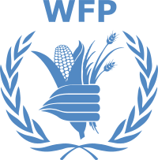

Courtesy: logo of WFP | wikipedia

## The birth of WFP:

“The World Food Programme (WFP) was created in 1961 as the organization in the United Nations system concerned exclusively with food aid, thereby providing an additional dimension to multilateral assistance”. Few international organizations have been created in personal proposal and unusual ways in which WFP was created. “The birth of WFP in 1961 was due to the inspiration of one man, George McGovern” At the time, George McGovern was the first director of the newly created Office of Food for Peace in the Executive Office of United States President John F. Kennedy and special assistant to him. It is important to understand this background as it left its mark on WFP that has remained to the present day. It headquartered in Rome and has office in 80 countries.

## Food for Development:

Although WFP had an important role to play in emergencies, its main focus of attention for most of the first 30 years of its operations was on using food aid in support of economic and social development projects. Two distinct phases may be discerned during this period: the first decade to the major watershed of the World Food Conference in 1974 during which WFP was faced with unstable and fluctuating resources and searched for a distinct identity; and much of the next 20 years during which project food aid was fully developed and institutionalized. The remaining years in the 1990s, during which emergency operations were to become WFP’s main concern.

World Food Programme resources, 1963–74 (US$ million)

Pledge period Proposed target 1 Approved target2 Resources pledged3

1963–65 100 100 85

1966–68 275 275 187

1969–70 200 200 320

1971–72 400 300 243

1973–74 400 340 359

1. Proposed by the WFP executive director and approved by the UN secretary-general and

FAO director-general.

2. Approved by the IGC and endorsed by ECOSOC and the UN General Assembly and the

FAO Council and Conference.

3 Resources pledged to WFP by the end of the pledging period

The first decade of WFP operations was dominated by concern about the instability and fluctuations of its resources, and the need to maintain a balance between pledges, commitments and disbursements. (Shaw, 2001)

## Managing Food Aid Resources:

A relatively small number of donors provided the majority of WFP’s resources, but many nations, including developing countries, made small, but symbolically important contributions. Over 100 countries have made contributions to WFP at one time or other. This has added to the strength and diversity of WFP’s resources. Miscellaneous income derived from donations, interest accruing from investment of WFP funds, insurance claims on commodities, and money paid to WFP for the discharge of WFP consignments ahead of schedule was also credited to WFP’s resources. Contributions could be accepted from intergovernmental bodies, other public sources as well as appropriate NGOs, but in reality, until recently, almost all resources have been provided by member states of the United Nations and FAO. Faced with declining resources, a concerted effort was made in the late 1990s to identify new non-traditional funding sources. For the first time, large food commodity contributions were obtained from the private sector. Relatively small contributions have been made over the years by farmer groups and private individuals. To date, the largest single private contribution has been $500,000 for refugees and displaced persons in Kosovo, Yugoslavia.

## WFP’s Strategic Plan:

Adopted just over a year after the 2030 Agenda for Sustainable Development, the World Food Programme (WFP)’s Strategic Plan for 2017-2021 aligns the organization’s work to the 2030 Agenda’s global call to action, which prioritizes efforts to end poverty, hunger and inequality, encompassing humanitarian as well as development efforts.

1. End hunger by protecting access to food.

2. Improve nutrition.

3. Achieve food security.

4. Support SDG implementation.

5. Partner for SDG results.

## WFP’s Strategic Goal:

1. Support countries to achieve zero hunger

2. Partner to support implementation of the SDGs

## WFP’s Strategic Result:

1. Everyone has access to food

2. No one suffers from malnutrition

3. Smallholders have improved food security and nutrition through improved productivity and incomes

4. Food systems are sustainable

5. Developing countries have strengthened capacities to implement the SDGs .

6. Policies to support sustainable development are coherent.

7. Developing countries access a range of financial resources for development investment.

8. Sharing of knowledge, expertise and technology, strengthen global partnership support to country efforts to achieve the SDGs.(WFP, 2016)

## Latest Development:

In 2019, WFP assisted 97 million people – the largest number since 2012 – in 88 countries. In 2019, WFP provided 4,2 million metric tons of food and US$2.1 billion of cash and vouchers. By buying food as close as possible to where it is needed, In 2019, WFP provided school meals to more than 17.3 million children in 50 countries, often in the hardest-to-reach areas. In 2020 WFP is awarded the Nobel Peace Prize.

# **World Health Organization ( WHO)**

## Introduction

World Health Organization is a specific office of the United Nations answerable for global public health. The WHO Constitution, which builds up the office's overseeing construction and standards, expresses its primary unbiased as the achievement by all people groups of the greatest conceivable degree of health. It is settled in Geneva, Switzerland, with six semi-independent territorial workplaces and 150 field workplaces around the world ("World Health Organization - Wikipedia", 2021). The WHO was set up by constitution on 7 April 1948, which is recognized as World Health Day. The primary gathering of the World Health Assembly. The WHO fused the resources, staff, and obligations of the League of Nations Health Organization and the Office International hygiene Public, including the International Classification of Diseases. Its work started decisively in 1951 after a critical implantation of monetary and specialized resources.

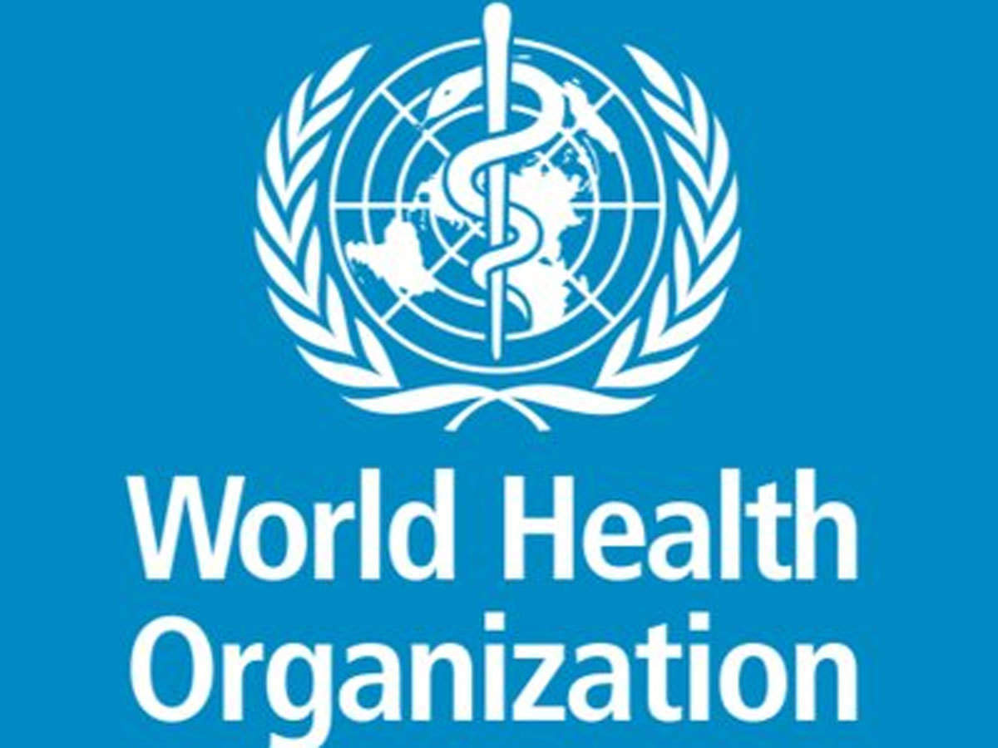

Courtesy: economictimes.indiatimes.com

## Background

The International Sanitary Conferences worked to combat many diseases, chief among them cholera, yellow fever, and the bubonic plague. The conferences were largely ineffective until the seventh, when an International Sanitary Convention that dealt with cholera was passed. Five years later, a convention for the plague was signed. In part as a result of the successes of the Conferences, the Pan-American Sanitary Bureau and the Office International hygiene Public were soon founded. When the League of Nations was formed, they established the Health Organization of the League of Nations. After World War II, the United Nations absorbed all the other health organizations, to form the WHO.

## Value

WHO, as the coordinating a lot expert on global wellbeing inside the United Nations framework, clings to the UN estimations of honesty, demonstrable skill. The estimations of the WHO labor force moreover mirror the standards of common freedoms, comprehensiveness and value set up in WHO's Constitution just as the moral norms of the Organization.

These qualities are enlivened by the WHO vision of a world in which all people groups achieve the most elevated conceivable degree of wellbeing, and our main goal to advance wellbeing, keep the world safe and serve the helpless, with quantifiable effect for individuals at country level. We are independently and altogether dedicated to incorporate these qualities.

## Activities

WHO works worldwide to advance wellbeing, keep the world safe, and serve the helpless. We will probably guarantee that a billion additional individuals have all-inclusive wellbeing inclusion, to shield a billion additional individuals from wellbeing crises, and furnish a further billion individuals with better wellbeing and prosperity.

For all inclusive wellbeing inclusion, we:

* + Focus on essential medical care to improve admittance to quality fundamental administrations
  + Work towards maintainable financing and monetary assurance
  + Improve admittance to fundamental medications and wellbeing items
  + Train the wellbeing labor force and exhort on work strategies
  + Support individuals' cooperation in public wellbeing strategies
  + Improve observing, information and data.

For health emergencies, we:

* + Prepare for crises by recognizing, alleviating and overseeing chances
  + Prevent crises and backing improvement of devices fundamental during episodes
  + Detect and react to intense wellbeing crises
  + Support conveyance of fundamental wellbeing administrations in delicate settings.

For health and wellbeing:

* + Address social determinants
  + Promote intersectoral approaches for wellbeing
  + Prioritize wellbeing taking all things together approaches and sound settings.

Through our work, we address:

* + Human capital across the life-course
  + Noncommunicable infections counteraction
  + Mental wellbeing advancement
  + Climate change in little island creating states
  + Antimicrobial obstruction
  + Elimination and annihilation of high-sway transmittable sicknesses.

## Policies and objectives

The WHO's Constitution states that its objective is the attainment by all people of the highest possible level of health. The WHO fulfills this objective through its functions as defined in its Constitution to act as the directing and coordinating authority on international health work . To establish and maintain effective collaboration with the United Nations, specialized agencies, governmental health administrations, professional groups and such other organizations as may be deemed appropriate. To assist Governments, upon request, in strengthening health services. ("World Health Organization - Wikipedia", 2021) To furnish appropriate technical assistance and, in emergencies, necessary aid upon the request or acceptance of Governments to promote co-operation among scientific and professional groups which contribute to the advancement of health. To propose conventions, agreements and regulations, and make recommendations with respect to international health matters and to perform.

## Response to the COVID-19 pandemic

While arranging the worldwide reaction to the COVID-19 pandemic and managing in excess of 35 crisis tasks for cholera, measles and different plagues internationally, WHO has been condemned for commending China's general wellbeing reaction to the emergency while looking to keep a conciliatory difficult exercise between the United States and China. ("World Health Organization's response to the COVID-19 pandemic - Wikipedia", 2021) Commentators including John Mackenzie of the WHO's crisis council and Anne Schacht of the US CDC have expressed that China's true count of cases and passing’s might be an underestimation. David Heyman, educator of irresistible sickness the study of disease transmission at the London School of Hygiene and Tropical Medicine, said accordingly that "China has been exceptionally straightforward and open in sharing its information. Also, they opened up the entirety of their records with the WHO.

## Administration and support

The excess two of WHO's thirteen recognized arrangement territories identify with the part of WHO itself. To give initiative, fortify administration and encourage association and joint effort with nations, the United Nations framework, and different partners to satisfy the order of WHO in propelling the worldwide wellbeing plan and to create and support WHO as an adaptable, learning association, empowering it to complete its command all the more productively and viably

# **References**

*Intergovernmental organization - Wikipedia*. (n.d.). Retrieved March 24, 2021, from https://en.wikipedia.org/wiki/Intergovernmental_organization

Shaw, D. J. (2001). The UN World Food Programme and the Development of Food Aid. In *The UN World Food Programme and the Development of Food Aid*. Palgrave Macmillan UK. https://doi.org/10.1057/9781403905437

WFP. (2016, November 1). *WFP Strategic Plan (2017-2021)* . World Food Programme. https://www.wfp.org/publications/wfp-strategic-plan-2017-2021

Heywood, A. (n.d.). *Politics.*

Islam Toriqul, & Karim Ershadul. (2019, September). *A Research Guide on the South Asian Association for Regional Cooperation (SAARC) - GlobaLex*. https://www.nyulawglobal.org/globalex/SAARC1.html

*South Asian Association for Regional Cooperation | Migrant Forum in Asia*. (n.d.). Retrieved March 24, 2021, from https://mfasia.org/mfa_programs/advocacy/south-asian-association-for-regional-cooperation/

*South Asian Association for Regional Cooperation - Wikipedia*. (n.d.). Retrieved March 24, 2021, from https://en.wikipedia.org/wiki/South_Asian_Association_for_Regional_Cooperation

*South Asian Association for Regional Cooperation (SAARC)*. (2019, September 3). https://www.drishtiias.com/important-institutions/drishti-specials-important-institutions-international-institution/south-asian-association-for-regional-cooperation-saarc

*List of intergovernmental organizations* . (n.d.). Retrieved March 21, 2021, from <https://en.wikipedia.org/wiki/List_of_intergovernmental_organizations#United_Nations_and_agencies>

*UNICEF*. (n.d.). Retrieved March 21, 2021, from <https://en.wikipedia.org/wiki/UNICEF>

*United Nations Office on Drugs and Crime* . (n.d.). Retrieved March 21, 2021, from <https://en.wikipedia.org/wiki/United_Nations_Office_on_Drugs_and_Crime>

*World Tourism Organization* . (n.d.). Retrieved March 21, 2021, from <https://en.wikipedia.org/wiki/World_Tourism_Organization>

World Health Organization - Wikipedia. (2021). Retrieved 20 March 2021, from <https://en.wikipedia.org/wiki/World_Health_Organization>

World Health Organization's response to the COVID-19 pandemic - Wikipedia. (2021).Retrieved 20 March 2021, from<https://en.wikipedia.org/wiki/World_Health_Organization%27s_response_to_the_COVID-19_pandemic>

**---------------------------------**